EPSON GPC - New CNP Storage Billing Requirement

Venue: Main Conference Room
Date : 31 Mar 2006
Time : 2:00 pm – 4:00 pm

Attendees:
Seng Hock
Annabelle
Chee Leong
Pei Fong

Introduction
EGPC would like to setup CNP air-con warehouse for overflow air-con storage environment.

With the new setup, total pallet location in CNP:
Non-air-con pallet location (NAC) = 3000
Air-con Pallet location (AC) = 7749

As such, new tier pricing might be used for CNP storage billing. Team has suggested below 3 options for the new billing approach / solution and below listed IT tasks required for each option.

Option 1:
To manage CNP non air-con W/H & air-con W/H as a whole
To impose Epson to fill up Air-con W/H locations first before storage overflow to Non-air-con W/H, with this will prevent loss for CNP Air-con W/H start-up investment.

Option 2:
To manage CNP non-air-con W/H & air-con W/H separately
Movement of physical parts is managed clearly
Disadvantage:
- Physical cargo identification management by air-con or non-air-con is tedious for operation;
- Tremendous numbers of MSITT jobs to be created to capture each movement,
which is redundant to admin and it could cause movement delay for operation;
- 3 year Air-con W/H startup investment not secured

Option 3:
To manage CNP as full air-con W/H (with 2 air-con rate)
To convert whole CNP warehouse to air-con environment. Operation will be easy to manage movement process and physical parts can be managed clearly in system and operation.

Revised Date: 2006.06.02 5:00PM From: Seng Hock:

Finalized CNP Billing as below:
Option 1: ** To manage CNP non air-con W/H & air-con W/H as a whole - CHANGE!
1. For billing from BAX to Epson - no changes.
Steps rate:
Between 1 to 3000 - Non-AirCon charge rate
From 3001 - Air-con Charge Rate

2. For billing from C&P to BAX, segregate Aircon and non Aircon.
Aircon location -Existing location from Aisle 78 odd, even to Aisle 84 odd, even.
Non-Aircon location - new location from Aisle 85 odd, even to Aisle 88, odd,even.

The logic for C&P billing to BAX remains unchanged - that is average for the whole month for both aircon and non aircon.

IT Task to facilitate new CNP storage billing: |  | Manday
S/N | Detail Description | Opt 1
1 | Overflow billing – Storage (BAX – Epson)  Opt1: Add new column C based on formula: C = A+B-3000 ;  if <0, then Non-Air con unit price applies;  if >=0, then storage pallet need to be segregate into 2 columns :3000 (Non-Air con rate) + C (Air con rate ) | 0.5
2 | Overflow billing – Storage (CNP– BAX)  Opt1: Segregate total on hand to 2 columns,  i.e. On hand Air-con and On hand Non Air-con  calculation to base on CNP location occupancy | 1
3 | Multiple-Site-Inventory-Tracking (MSITT)  Opt1: No change required. | 0
4 | Location Setup  - Add new Zone (sectionkey) to segregate AC and NAC locations.  CNP Air-Con Location : CNPAC  CNP non Air-Con Location : CNPNAC  - Setup Air-con locations | 0.5
5 | SLIM changes  Changes to the SLIM linkage that currently feeding the report values for invoicing | 1
6 | Location occupancy  Add NON-Aircon Locations zone | 1
 | Total Mandays | 4

Other effected Objects:
- Pick List
- CNP Pull By PickTicket
- CNP Pull By PickTicket (LP Picking)
- MSITT – CNP Checking

 | Library | Objects | remarks
1 | gpc_sitetosite.pbl | uo_gpc_transport | Dw_data.Itemchanged
2 |  | r_gpc_cnp_pull_request_by_pickticket_lp
3 |  | r_gpc_cnp_pull_request_by_pickticket
4 |  | r_gpc_tp_transfer_progress
5 | gpc_outbound.pbl | r_gpc_picklist
6 |  | r_gpc_picklist_scrap
7 | gpc_setup.pbl | r_gpc_tp_transfer_progress

Changed Reports:

- Overflow billing – Storage (BAX – Epson)
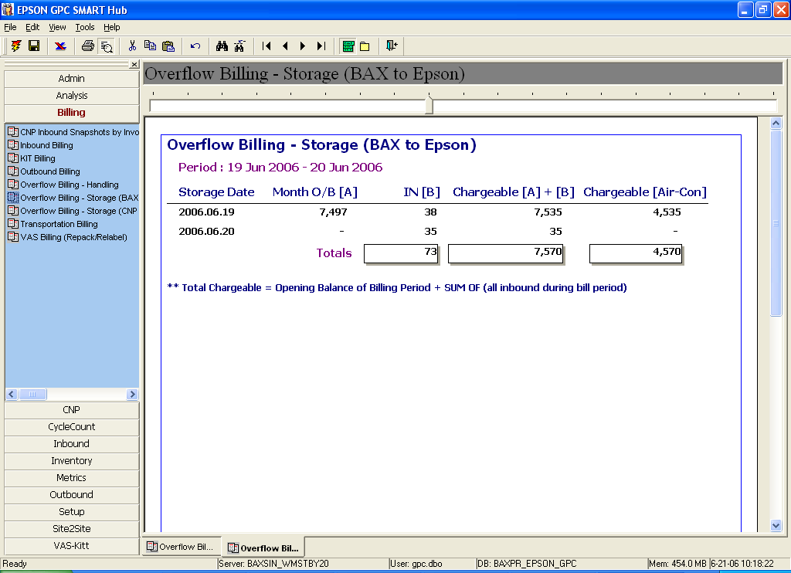

- Overflow billing – Storage (CNP– BAX )

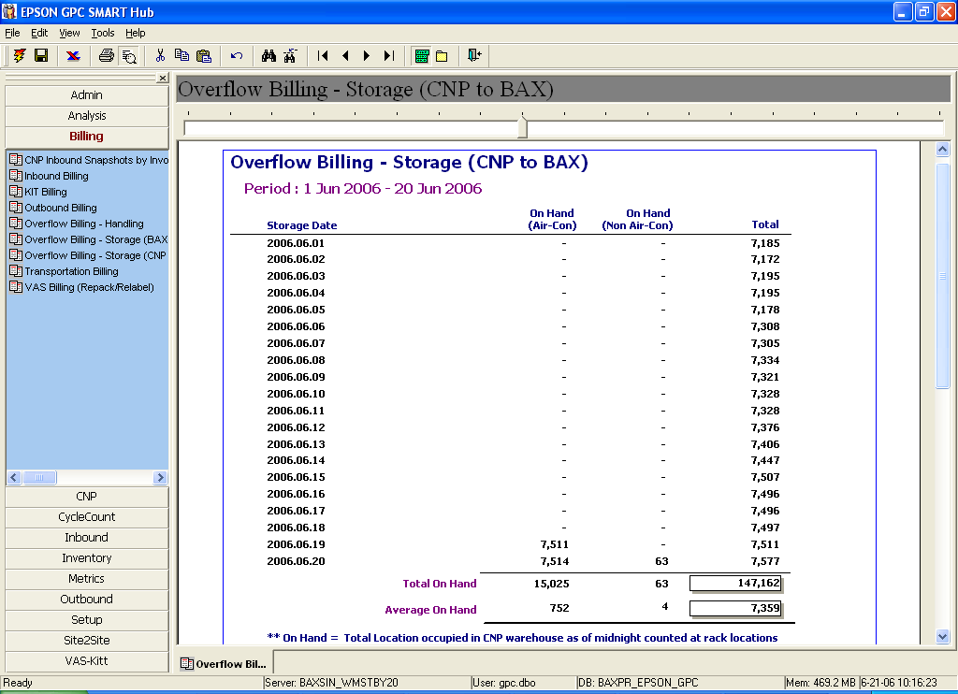

- Location occupancy V2
